1. In the below elements which of them are values or an expression? eg:- values can be
integer or string and expressions will be mathematical operators.

* - Expression

‘hello’ - String

-87.8 - Float

- - Expression

/ - Expression

+ - Expression

6 - Integer

- What is the difference between string and variable?

Ans: Variable is a property which can take any variables

String is a type of variable , It takes the data in Alphabetical manner in enclosed with quote. It is one of the datatypes in python.

- Describe three different data types.

Ans: 1.String - Always contain text ,For Ex ( “Hello”)
- Integer - contain Numeric , for Ex ( 1,34)
- Float - contain Numeric in decimal format , for ex ( 84.5, 90.7)

4. What is an expression made up of? What do all expressions do?

Ans: An expression is a combination of operators and operands that is Interpreted to produce some other value. A sequence operands and operators , like a+b-5 is called an expression.python supports many operators for combining data objects into expressions.

5. This assignment statements, like spam = 10. What is the difference between an
expression and a statement?

Ans: An assignment assigns a value to variable, value = 10 is assigned to variable (Spam).An expression performs some operation and return the result value.

- After running the following code, what does the variable bacon contain?
bacon = 22
bacon + 1

Ans: variable bacon contain will contain 22

7. What should the values of the following two terms be?

‘spam’+ ’spamspam’
‘spam’ * 3

Ans: spamspamspam will outcome of ‘spam’+ ‘spamspam’
Spamspamspam will outcome of ‘spam’ * 3

8. Why is eggs a valid variable name while 100 is invalid?

Ans: According the rule variable should always begin a_ or character and cannot begin with number.

9. What three functions can be used to get the integer, floating-point number, or string
version of a value?

Ans: single Input can be converted into an Integer,string and float in the following way (Image Attached)

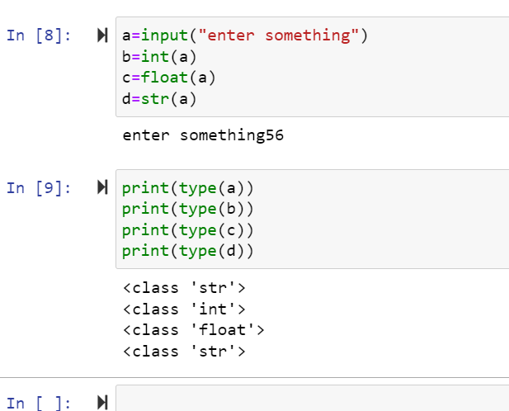

10. Why does this expression cause an error? How can you fix it?

‘I have eaten’ + 99 + ‘burritos’

Ans: This expression will cause error because operation cannot be performed in Data types.

‘I have eaten’ [Str] + 99 [Int] + ‘burritos’[Str]

This expression can be fixed when you convert in single datatypes . like 99 should be in quotes

Fixed Expression - ‘I have eaten’ [Str] + ‘99’ [str] + ‘burritos’[Str]

